2100998 이수찬 C++ 과제 5-5장
- 과제1
#include<iostream>
using namespace std;

class Circle {
private:
int radius;
public:
Circle(int r);
void setRadius(int r);
int getRadius();
};
Circle::Circle(int r=1){
radius = r;
}
void Circle::setRadius(int r) {
radius = r;
}
int Circle::getRadius() {
return radius;
}

void swap(Circle& c1, Circle& c2) {
Circle temp = c1;
c1 = c2;
c2 = temp;
}

int main() {
Circle c1(5);
Circle c2(10);

cout << "교환 전:" << endl;
cout << "c1의 반지름: " << c1.getRadius() << endl;
cout << "c2의 반지름: " << c2.getRadius() << endl;

swap(c1, c2);

cout << "\n교환 후:" << endl;
cout << "c1의 반지름: " << c1.getRadius() << endl;
cout << "c2의 반지름: " << c2.getRadius() << endl;

return 0;
}

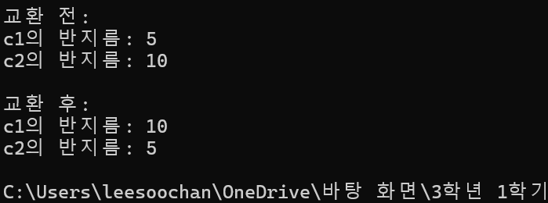

- 과제2
#include<iostream>
using namespace std;

class Num {
private:
int num;
public:
Num(double n);
};

Num::Num(double n){
num = n;
}

void half(double &num1) {
/*double num;
num = num1;
double temp = num/2; */
num1= num1 / 2;
}

int main() {
double n = 20;
half(n);
cout << n;
}
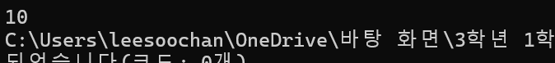

- 과제3
#include<iostream>
using namespace std;

string combine(string &text1, string &text2, string &text3) {
return text3 = text1 + text2 ;
}

int main() {
string text1(" I love you "), text2("very much");
string text3;
combine(text1, text2, text3);
cout << text3;

}

